What was required to be done:

1. In the caretaker web login we’ll give an option to set a reminder for any property managed by the care taker. This could be for a property / multiple properties, or for a unit / multiple units in a property. done

2. The above option will also be available in the admin login. The relevant caretaker will get the reminder. We are not able to select the project and unit in the admin login

3. A reminder will be sent via Push Notification to the caretaker. Not Done. The caretaker did not receive a push notification for the reminder

4. The event will be added to the caretaker’s google calendar. Need to check this

5. Option in the caretaker app to complete the task and enter the completion date and a comment, Not done. There is no option to see the calendar/upcoming reminders/complete the tasks on the VCare app which will be viewable by admin in a list. Can also generate a notification for the admin Unable to see this option

6. Daily notification to caretaker, from a day before the due date till the time the task is not completed. Not done

7. Notification to admin for incomplete task, three days after a task is due and not completed. This is showing in the summary on admin web login

8. On the caretaker app, the users currently also have access to the details homeowners of the project. We would like to remove this access for all projects. done

9. On the backend we have an option named Sub-Users, it is used to create more logins for backend with limited access to the information. Currently, we are unable to create reminders and see the summary of the outstanding tasks with the sub-users. The information does not show up anywhere and needs to be manually collated. We need to figure out a way to put this together. done

11. Also with respect to the sub-users, when we share access to MIS, the user gets information for all the projects. We would like to share MIS reports of limited projects with the sub-users. done  
12. we would require an option to give access to limited projects to the sub-users for reminders. done

Feedback:

1. In the Admin login, we are unable to choose the Project/Unit and Caretaker.

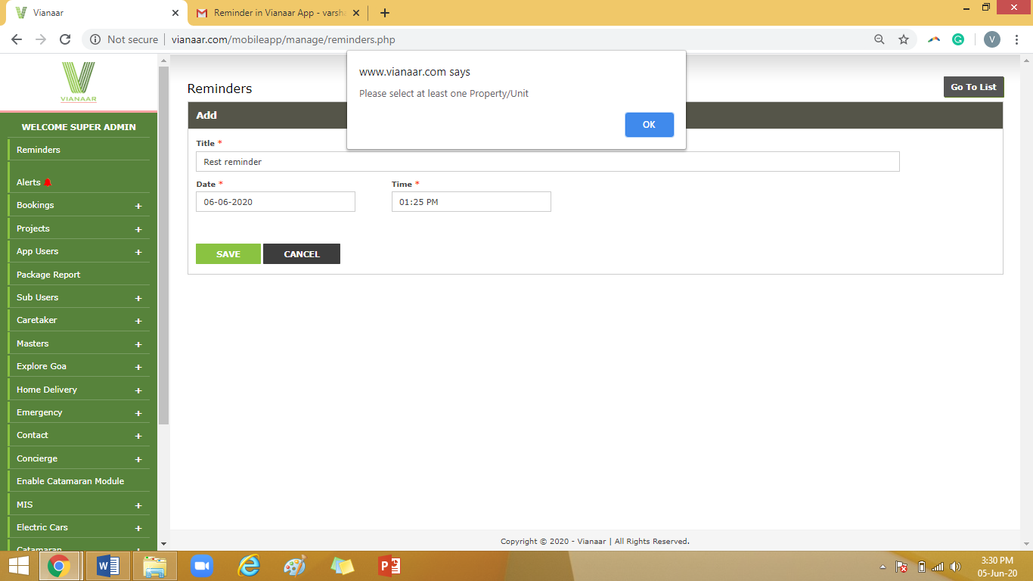

1. We tried to add the tasks from the web login of caretakers, but it is not getting saved:

